**Computer Science Program**

3rd Semester 2015

**Semester Project**

**Implementation of the POCA app**

|  |  |
| --- | --- |
| **The report has been prepared by :** | **Supervisor:** |
| Alexandru Draghi |  |
| Ionut Danci Bumbea | Gianna Bellé |
| Leonard Hirja | Date of submission: |
| Richard Retezi | 14-12-2015 |
|  |  |



Contents

1. Introduction 3

2. Idea Generation 3

**2.1** **P.O.C.A mobile application / website** 3

3. Technology 4

**3.1** **WCF Service** 4

**3.2** **Client and Server** 6

**3.3** **Chosen Architecture** 6

**3.4** **Design** 6

**3.5** **Communication Protocols2** 7

**3.6** **Concurrency3** 8

**3.7** **Database Transactions** 8

**3.8** **Setup and Hosting** 9

**3.9** **Firewall** 10

4. Programming 10

**4.1 ASP.Net4** 10

**4.2 Premium Package Purchase** 10

**4.3 Searching** 10

**4.4 Connections** 11

**4.5 Messages** 12

**4.6 Hosting on azure** 12

**4.7 Implementation** 13

5. Conclusions 13

5. References 14

6. Appendix 14

# Introduction

When it comes to selecting a project that could fit the requirements group 2 had to choose between lots and lots of idea. The members had many interesting ideas, most of them not practical or too hard to do in this very short period of time. The group found a very interesting idea when the options were given: a website, a desktop client or a windows phone application.

The only one that had a change to be a little more complicated was the windows phone application. The project had to be build using C sharp, has to have a client – server connection, high complexity, concurrency problems solving and some security measures needs to be taken.

Regarding to the programming and the technology part group 2 had to come up this an idea that could satisfy the mentioned criteria.

# Idea Generation

At the start an idea for the project was needed. The members of Group 2 started to write down ideas on different sheets of papers. After everyone had written down at least 4-5 ideas individually, these ideas were evaluated. There was one single rule: There are no rules. Group 2 let its imagination fly.

Some ideas were very distant from each other, while others were relatively similar. The ideas were grouped together according to similar thematic and/or platform. After the grouping, each idea was anonymously evaluated. Some of them were discarded instantly, some were kept for future possible consideration or for reserve, while some made the best candidates for the project. A short list was created and in the end, one idea was selected for the project as a common agreement. In the next section, a short description of the selected idea is presented.

## **P.O.C.A mobile application / website**

The idea was simple: There are lots of young professionals, scattered around the world, who are really interested and/or good in a given area of study and there is a matter they would like to discuss with people with the similar interests.

Using modern technology, it would be really nice if they had an app that can find people who share the same passion and provide a field for them to be able to contact and communicate to each other. Using a mobile application they could search through different predefined “passions” and find people of the same interest within their area of living or even anywhere else around the world. When a user finds a person with the same interest he/she can send a request for contact and that person can accept the request. Then, a match is being established and they can start discussing the topics they’d like via chat. In case of multiple people want to discuss a matter, a group chat is possible.

This idea can help lots of people who need a platform to share their thoughts and ideas with others who could be interested in the topic. Of course, there were some problems along the way. The mobile application had to be changed to a website but the functionality stood the same. Same principals and same simple interface are used.

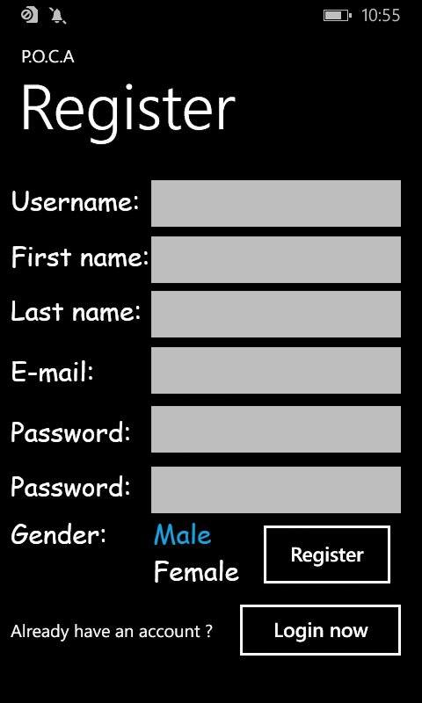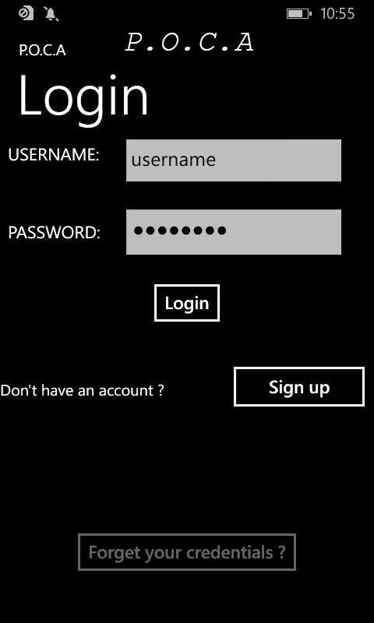

# Technology

## **WCF Service**

Windows Communication Foundation1 (WCF) is a framework for building service-oriented applications. Using WCF, you can send data as asynchronous messages from one service endpoint to another. A service endpoint can be part of a continuously available service hosted by IIS, or it can be a service hosted in an application. An endpoint can be a client of a service that requests data from a service endpoint.

In this project the WCF service is used to call the database every time a user is logging in, logging out, registering and so on. The WCF service is hosted on Azure and it’s connected to the website as a reference. The WCF service has also access to the database used to store all the needed information.

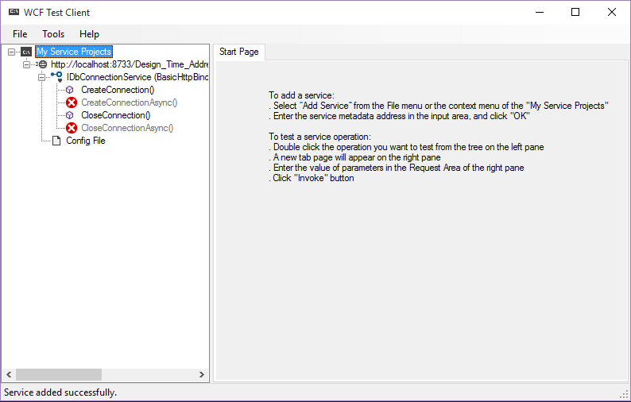

**3.2 VPN and Wireless**

As part of the project a VPN network had to be created to test the functionality of the WCF service, the connection between the client and the server, data transfer and so on without depending on the outside network. A Wireless VPN is a local (lan) connection created using one computer that allows other computers to connect to it and to each other and allows then to share information faster and safer.

The advantages are quite obvious: faster speed and connection rate, no outside threats or viruses, easy to setup. One biggest disadvantage is that testing is done very hard when it comes to multiple users from different locations. For this reason only the group decided to use a service from Microsoft called Azure to host the database, the services and the website. This allows all users to connect at the same time and test all functions.

Azure works 24 hours per day with backup created every few minutes, so, if anything goes wrong the project is backed up safety on their servers and there’s always a possibility to recover an older version of it.

## **Client and Server**

A client is a machine that gets input from the user and then communicates with another device in order to perform some actions. A server is a local or remote device that is waiting for a client to give him something to do. A server is connected to a client by another medium (Browser, FTP) and can be asked to write, delete or modify data. The information that is return by the server is then displayed back by the client. For this project the client is a phone application / website where the user can create a profile and logging. After logging the users can search for other users. This action is demanding the server to look into the database and to return all other users that meet the requirements.

## **Chosen Architecture**

For this project the group decided to follow the classic web architecture format. The initial decision was to create a windows phone application but the WCS service was not compatible with what windows phone was offering. After a quick rethink of the problem the group chose to create a website by following the same principals and implementing the same functionality.

As a pro feature is that not, the website will be available not only on windows phone but also on desktops, laptops, tables and any other device that have a supporting browser. Changing and updating the website is also done easily since there is no need for and update from the user. Websites have a very big disadvantage if they were to be compared with app or desktop applications because they are not directly visible at any given moment in time. An app is always on the screen when the phone is unlocked, but a website need to be reminded or bookmarker in other not to be forgotten by the user.

## **Design**

When starting to develop the project the design had to be kept in mind. One of the most important part is not just the interface but also the architectural design, the way the project is build.

The interface is very simple and intuitive. The website starts by showing a login window, with the possibility to switch to a register page. After the login, the user can then go to the main page where all the important information is. A list with all the people that meet your requirements is shown.

The project is build using a few times of pages and services. The languages that are used are HTML5, C# and SQL. The SQL queries are used to connect and transfer information from and to the database. C# is used to write the response methods for every button and fields that are connected to the interface written using html. The services are also written using C#. A concrete structure is used, therefore in the WCF service we have the Model and the Database Layer, the website contains the Control and the GUI layer.

## **Communication Protocols2**

As communication protocols the website is using HTTP protocol and the TCP/IP protocol. The HTTP protocol is used primary by the World Wide Web and it makes the connection between a web browser on the client’s machine and a webserver hosted somewhere in the world. The information is carried over TCP/IP and this way the client communicates with the serves and the information travels back and forward. HTTP is a stateless and connectionless protocol.

This protocols are very easy to be implemented and to be used. If there is a lack of security software then the information sent over http is very easy to be captured by a third party software and modified or retransmitted.

Also, the send packages have no guaranty that they will be received by the server since the server is only sending answers to requests. For a searching and matching application this implementation is exactly what it is needed and the lacks of this protocol will not affect the functionality of the website in any way.

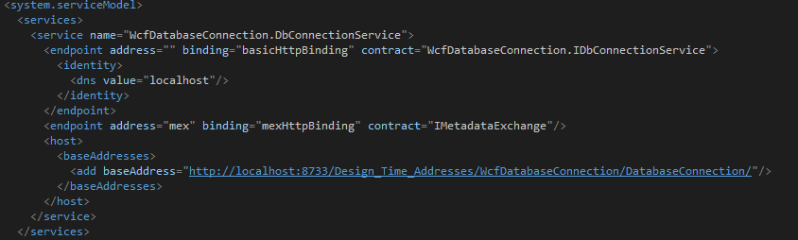

## **Concurrency3**

The project is created based on a free to use system. The group had to think of a way to implement the concurrency without affecting the rest of the functions. The first option was the introduction of a paid help desk for users. The system would allow then every user to book an appointment with an expert to help him solve his problems.

The concurrency would occur when two or more people try to book the same expert at the same time for the same period. A solution would be to allow every first user to have a 10 to 15 minutes booking trial, this means in this project a LOCK pattern will be used. That expert and period would appear booked for every other user in that period.

An obvious disadvantage here is that the expert could remain not booked if the initial user would decide not to book that period after all. In the same time this solution is excluding any further concurrency problem for help booking.

The second option the group had to consider was the procession of received messages and notifications. If a user receives two messages from two different users at the same time, which one should be first displayed. Since this concurrency problem is not really affecting the functionality of the system the display order with be determined by the order the messages were written in the database.

There are no problems when it comes to displaying messages since there order is not changing the context of the message.

## **Database Transactions**

Every time when working with database there is this question that come along. Is the information sent complete and correct? To solve this problem in our project we used database transactions. A transaction is a sequence of operations performed as a single logical unit of work. This way when we have to write information in two different place we either write both or none. If there is a problem with the connection is transaction is cancelled and the information is return to the initial value.

When a transaction is completed the transaction is also successful. The information is replaced and a success messages is returned. The group is using transactions to assure that the users are connected with the write users and that they have purchased the correct premium packages. Every time when a writing database action is needed it comes packed in a transaction.

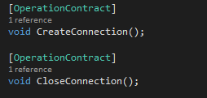

## **Setup and Hosting**

Before starting working on the project the setup had to be done. A laptop is necessary equipped with visual studio, SQL management studio, Microsoft office and much more. Visual studio allows users to publish directly online.

As group 2 is using Azure to deploy the project, another services offered by Microsoft, it is very easy to publish. All services are fully supported by Azure. The only modification needed is the address of the WCF service that needs to be updated.

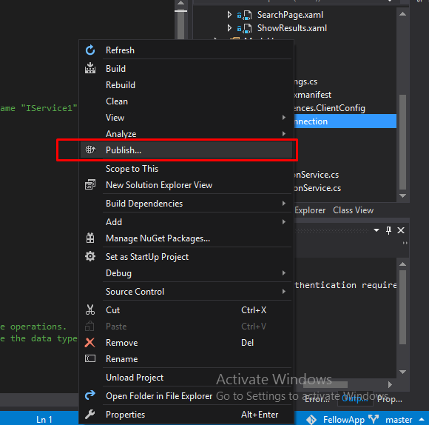

## **Firewall**

Azure offers a firewall along with all other services. A firewall is used to allow or decline connections if the data is threatening. You can define server-level and database-level firewall settings for the master or a user database in your Azure SQL Database server to selectively allow access to the database.

# 4. Programming

## **4.1 ASP.Net4**

The website is done using ASP.Net. The languages that are used to create the website are C# and HTML5. ASP.NET is an [open-source](https://en.wikipedia.org/wiki/Open_source) [server-side](https://en.wikipedia.org/wiki/Server-side_scripting) [web application framework](https://en.wikipedia.org/wiki/Web_application_framework) designed for [web development](https://en.wikipedia.org/wiki/Web_development) to produce [dynamic web pages](https://en.wikipedia.org/wiki/Dynamic_web_page). It was developed by [Microsoft](https://en.wikipedia.org/wiki/Microsoft) to allow [programmers](https://en.wikipedia.org/wiki/Programmer) to build dynamic [web sites](https://en.wikipedia.org/wiki/Web_site), [web applications](https://en.wikipedia.org/wiki/Web_application) and [web services](https://en.wikipedia.org/wiki/Web_service).

## **4.2 Premium Package Purchase**

The need for a premium package purchase appear when the project had to have a concurrency problem. The premium package allows users to book an appointment with an expert at a certain point in time. The problem is a concurrency one since multiple users could book the same expert at the exact same time.

## **4.3 Searching**

Searching allows user to find each other using some predetermined fields like distance, age, passions. When the search buttons is pressed the database is queried and the results are returned and shown on the screen. Users can browse them and select other users, add connections or search again.

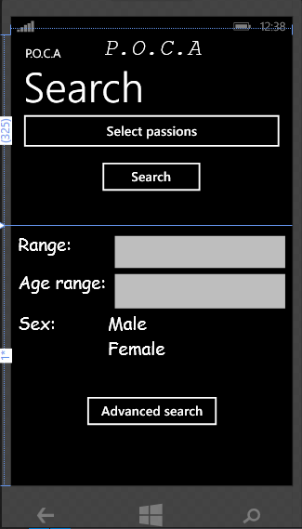

## **4.4 Connections**

A connection is represented by a relationship between two users. When a user looks at another’s user profile he can also send him a connection request. If the other user accepts them the users are connected and they can send messages to each other, add each other to chat groups and participate to projects together. Once the users are connected they can also remove connections if they do not need them anymore.

## **4.5 Messages**

Messages are used by the users to connect with each other. A user is allow to send a message to another user only if they are connected. The users can also create groups to send the same message to multiple users.

This function is useful is they are working to the same project, for example. The messages are saved into the database until the user is connected and it’s allowed to receive the message. After that, the messages are saved locally and deleted from database.

## **4.6 Hosting on azure**

Azure is a service provided by Microsoft that allows users to host multiple types of website, services, applications and much more. Not only that, azure also supports SQL database and everything that’s required for this project out of the box.

Visual studio is directly connected to Azure using a very simple interface. To deploy it’s as simple as pressing Publish on Azure.

The group had to think of ways to present the project. Even if the project could run just fine on a local computer this would defy the whole purpose of the project. The group wanted to create something real. So it has been decided to create host the WCF Services, the website and the database on Microsoft’s Azure servers. This way a more natural connection is made to an outside server. The requests and the answers are clear.

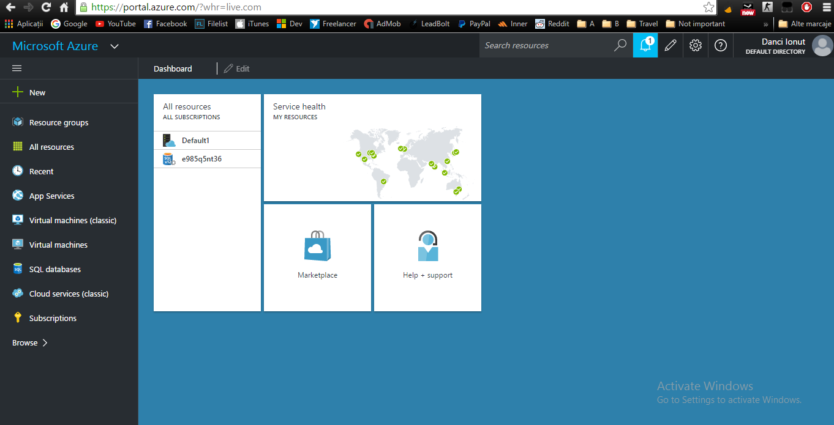

## **4.7 Implementation**

The project consist of a website that allows user to create a profile then select passions and connect to other users that have the same passions. The website only contains the design part and the login is hidden in the WCF service. The user data is stored in a database hosted on Azure.

The website also allows users to purchase help at a certain data and time for a very low fee. An expert will help them solve their problem. Users can communicate with each other using personal messages, they can add new users to connection, remove old users, create group and so on. This features allows then to create the perfect interface to make communication easy.

# 5. Conclusions

The POCA up was the best idea among many the members of the group could come up with. It consists a huge potential and later releases and fixes can add true value. The group started working on this project with great enthusiasm and positiveness.

We decided to take on a big challenge and implement our program on a Phone. Unfortunately the challenge was far greater than we thought before and it was not because of the lack of knowledge or skills, but because of the lack of software support among the different IT tools. We have spent a lot of time trying to solve the challenge, but in the end we switched in order to meet with the original requirements and launch our app on a web, using a website and a webserver. The rest of the designing and a programming went well how it was supposed to be.

The group believes that the fact and the volume of the challenge and obstacles we have faced with and that we could take the responsibility and the risk to switch to the web application means that the Agile Development Method worked and it was immensely crucial and useful for us.

Although we had some communication errors and time-lags we could resolve it in the end and work together in order to finalize the project. This project has shown us what huge risks and challenge can surface when choosing a new architecture or platform, how the lack of support between software can ruin everything, how important internal communication is and how to tackle down obstacles even if it means to take responsibility and risks in order to meet with the requirements.

We have learned what our individual and group-wise mistakes are and how to resolve or minimize them for the sake of the success of the project. This project had a big and hard learning curve and we consider it as a huge personal and professional development for our team.

# References

1 - https://msdn.microsoft.com/en-us/ (2015)

2 - <http://www.protocols.com/> (2015)

3 - <https://en.wikipedia.org/wiki/Concurrency_(computer_science)>

4 - http://www.asp.net/

# Appendix